SUPPLEMENTARY MATERIAL

Evidence of introgressive hybridization between Stenella coeruleoalba and Delphinus delphis in the Greek Seas

Aglaia Antoniou, Alexandros Frantzis, Paraskevi Alexiadou, Nefeli Paschou, Nikos Poulakakis

Table S1: Details of the skin samples of striped and short-beaked common dolphins collected from the Greek Seas and analyzed in the present study (SG: Saronic Gulf, GoP: Gulf of Patras, GOC: Gulf of Corinth). At the species column, super scripts define samples that were characterized as genetically intermediates by three methods (F: FCA, P: PCA and D: DAPC). In Sex column, the sex based on genetic / morphological data is shown. Question mark (?) indicates ambiguous result, while dash line (-) denotes the specimens that we failed to use in the genetic analyses due to low quality of DNA or there were not morphological data. At the Microsatellites data column, the number of successfully genotyped loci for each sample is appended.

Id Code | Species | Latitude | Longitude | Sea | Sampling Date | Sex  Genetic/Morphology | Cytochrome b Accession No | Microsatellites data
1 | S. coeruleoalba | 37.84 | 23.76 | SG | 22/5/1999 | -/M | - | 4
2 | S. coeruleoalba ^{F,P,D} | 39.47 | 19.94 | Ionian | 2/4/2001 | -/- | - | 9
3 | S. coeruleoalba | 37.82 | 23.81 | SG | 31/1/2001 | F/F | MH898778 | 11
4 | S. coeruleoalba | 38.14 | 22.49 | GOC | 13/8/2001 | F/F | MH898768 | 8
5 | S. coeruleoalba | 37.11 | 25.38 | Aegean | 11/7/2003 | M/M | MH898757 | 11
6 | S. coeruleoalba | 39.44 | 20.04 | Ionian | 31/5/2005 | -/F | - | 1
7 | S. coeruleoalba ^{F,P,D} | 36.89 | 22.23 | Ionian | 21/3/2007 | F?/M | MH898765 | 8
8 | S. coeruleoalba | 38.06 | 23.04 | GOC | 27/1/2008 | F/F | MH898760 | 10
9 | S. coeruleoalba ^{F,P,D} | 37.10 | 25.37 | Aegean | 24/3/2009 | M?/M | MH898743 | 10
10 | S. coeruleoalba | 38.13 | 22.45 | GOC | 6/2/2010 | F/F | MH898755 | 10
11 | S. coeruleoalba | 37.16 | 24.52 | Aegean | 26/3/2010 | M/- | MH898776 | 9
12 | S. coeruleoalba | 37.94 | 22.92 | GOC | 10/8/2010 | F/- | MH898747 | 9
13 | S. coeruleoalba | 37.63 | 25.15 | Aegean | 26/8/2010 | F/- | MH898758 | 6
14 | S. coeruleoalba | 37.96 | 22.81 | GOC | 30/8/2010 | M/- | MH898761 | 11
15 | S. coeruleoalba ^{F,P,D} | 37.81 | 24.07 | Aegean | 2/9/2010 | M/M | MH898771 | 10
16 | S. coeruleoalba | 37.97 | 24.48 | Aegean | 19/11/2010 | F?/- | MH898766 | 10
17 | S. coeruleoalba | 35.34 | 25.34 | Cretan | 12/12/2010 | F/F | MH898748 | 9
18 | S. coeruleoalba | 38.11 | 22.53 | GOC | 4/1/2011 | M/M? | MH898738 | 10
19 | S. coeruleoalba | 38.13 | 22.45 | GOC | 26/1/2011 | M/M | MH898763 | 11
20 | S. coeruleoalba | 38.39 | 21.92 | Aegean | 1/3/2011 | M/M | MH898739 | 11
21 | S. coeruleoalba ^{F,P,D} | 38.34 | 21.85 | GoP | 14/3/2011 | F/F | MH898744 | 9
22 | S. coeruleoalba | 38.27 | 22.07 | GOC | 16/3/2011 | M/M | MH898740 | 11
23 | S. coeruleoalba | 38.35 | 22.22 | GOC | 23/3/2011 | M/M? | MH898745 | 11
24 | S. coeruleoalba | 38.27 | 22.07 | GOC | 26/3/2011 | M/M | MH898775 | 9
25 | S. coeruleoalba | 39.01 | 26.17 | Aegean | 29/3/2011 | -/M? | - | 5
26 | S. coeruleoalba | 37.73 | 23.91 | GoS | 5/4/2011 | M/- | MH898749 | 9
27 | S. coeruleoalba | 37.02 | 25.25 | Aegean | 14/4/2011 | M/- | MH898767 | 11
28 | S. coeruleoalba | 38.37 | 21.79 | GoP | 20/4/2011 | M/M? | MH898741 | 9
29 | S. coeruleoalba | 38.36 | 22.23 | GOC | 24/4/2011 | F/- | MH898746 | 10
30 | S. coeruleoalba | 38.39 | 21.92 | GOC | 26/4/2011 | M/- | MH898750 | 11
31 | S. coeruleoalba ^{F,P,D} | 36.84 | 27.32 | Aegean | 30/4/2011 | M?/M | MH898777 | 8
32 | S. coeruleoalba | 37.93 | 21.19 | Ionian | 7/5/2011 | F/F | MH898762 | 11
33 | S. coeruleoalba | 37.63 | 25.15 | Aegean | 29/8/2011 | F/- | MH898751 | 8
34 | S. coeruleoalba ^{F,P,D} | 37.81 | 21.23 | Ionian | 10/1/2012 | M/M | MH898742 | 11
35 | S. coeruleoalba | 39.55 | 19.91 | Ionian | 10/2/2012 | M/M | MH898752 | 9
36 | S. coeruleoalba | 38.84 | 20.68 | Ionian | 16/3/2012 | M?/F | MH898769 | 6
37 | S. coeruleoalba | 38.29 | 21.76 | GoP | 18/3/2012 | F/F | MH898753 | 8
39 | S. coeruleoalba | 38.06 | 23.04 | GOC | 17/5/2011 | F/- | MH898785 | 4
40 | S. coeruleoalba ^{F,P,D} | 38.15 | 23.22 | GOC | 21/5/2011 | F/F | MH898770 | 6
41 | S. coeruleoalba | 35.49 | 27.12 | Aegean | 21/2/2012 | M/M | MH898754 | 10
53 | S. coeruleoalba ^{F,P,D} | 38.09 | 23.18 | GOC | 27/12/2012 | F?/M | MH898759 | 7
54 | S. coeruleoalba | 39.82 | 19.86 | Ionian | 20/2/2013 | F/F | MH898793 | 11
55 | S. coeruleoalba | 38.11 | 23.22 | GOC | 13/4/2013 | F/M? | MH898792 | 5
56 | S. coeruleoalba | 38.35 | 22.22 | GOC | 26/4/2013 | F/F | MH898783 | 10
60 | S. coeruleoalba | 38.00 | 22.77 | GOC | 26/10/2013 | -/- | MH898791 | 10
38 | D. delphis | 36.52 | 27.78 | Aegean | 4/5/1999 | M/M | MH898787 | 1
42 | D. delphis | 37.93 | 23.62 | Aegean | 15/10/1997 | -/M | MH898786 | 8
43 | D. delphis | 38.01 | 21.29 | Ionian | 14/2/2006 | F/F | MH898784 | 11
44 | D. delphis | 39.05 | 26.06 | Aegean | 12/5/2008 | F/F | MH898790 | 10
45 | D. delphis | 36.94 | 25.01 | Aegean | 2/5/2010 | M/- | MH898780 | 9
46 | D. delphis | 40.59 | 23.78 | Aegean | 14/2/2010 | F/F | MH898779 | 3
47 | D. delphis ^{F,P,D} | 36.76 | 22.58 | Aegean | 5/4/2011 | F/F | MH898781 | 7
48 | D. delphis | 39.05 | 26.06 | Aegean | 14/5/2011 | F/F? | MH898772 | 10
49 | D. delphis | 38.05 | 23.04 | GOC | 28/7/2011 | M/- | MH898764 | 9
57 | D. delphis ^{F} | 40.84 | 25.86 | Aegean | 14/3/2013 | M/M | MH898773 | 11
58 | D. delphis | 40.85 | 25.79 | Aegean | 2/4/2013 | M/M | MH898756 | 10
59 | D. delphis ^{F,P,D} | 36.67 | 25.27 | Aegean | 6/6/2013 | M/M | MH898782 | 7
50 | Intermediate morph | 38.21 | 22.50 | GOC | 20/8/2010 | F?/- | MH898789 | 10
51 | Intermediate morph | 38.05 | 23.04 | GOC | 24/7/2011 | F/- | MH898788 | 11
52 | Intermediate morph | 38.05 | 23.04 | GOC | 24/7/2011 | F?/- | MH898774 | 10

Table S2: Microsatellite loci details and polymerase chain reaction (PCR) panel. Thermocycling: 95 °C for 4 min, followed by 35 cycles of denaturation at 94 °C for 30 s, annealing (variable temperatures, see T_{a}) for 60 s and extension at 72 °C for 60 s. Final extension at 60 °C for 30 min.
Locus | Primer sequence (5′−3′) | Repeat motif | Label | T_{a}(°C) | Reference
Dde09 | F: GAAGATTTTACCCTGCCTGTC  R: GATCTGTGCTCCTTAGGGAAA | (CTAT)₁₀ | HEX | 51.8 | Coughlan et al. (2006)
Dde59 | F: ACACAGCTTACTTACCTTACCAA  R: GTCCCTTTGAGCAGAGTTCTA | (GATA)n | HEX | 48.6 | Coughlan et al. (2006)
Dde61 | F: CTGAACCTGAGTTCGGTAACA  R: TGAGCAATACACATATGCACCT | (CTAT)8 | FAM | 60 | Coughlan et al. (2006)
Dde65 | F: GGTAGTCGTAGGGAAAGGGTA  R: AGCAGCCCTAGCAACCTTATA | (CTAT)₁₃ | HEX | 47.9 | Coughlan et al. (2006)
Dde66 | F: AACATTGCCAGTGCCTTAGAA  R: GTGGAACAGACGCGCATAT | (GT)₁₉ | FAM | 59 | Coughlan et al. (2006)
Dde70 | F: ACACCAGCACCTACATTCACA  R: TCAGCAGCATTCTAACCAAAC | (CA)₂₁ | HEX | 57.4 | Coughlan et al. (2006)
Dde72 | F: TGCTCAACAGATTTCACACTT  R: AAGGAAACAAAGTATCTGAGCA | (CTAT)₁₅ | FAM | 47 | Coughlan et al. (2006)
Dde84 | F: AATAATCCTTTGTGGTTTCTGTT  R: CATTCCAGGTACAGCTTTTCA | (CA)₂₂ | HEX | 47.9 | Coughlan et al. (2006)
MK3 | F: TGCATTCATGTAAAGGTGCG  R: CTGCAACTAGAGAAAGCCCG | (A)₉TAC(GT)₁₅AT(GT)₇ | ROX | 59 | Krutzen et al. (2001)
MK5 | F: CTCAGAGGGAAATGAGGCTG  R: TGTCTAGAGGTCAAAGCCTTCC | (TG)₁₃CT(TG)₂CA(TG)₂(TA)₂(TG)₄ | FAM | 57.4 | Krutzen et al. (2001)
EV14 | F: TAAACATCAAAGCAGACCCC  R: CCAGAGCCAAGGTCAAGAG | (GT)₁₁ | FAM | 51.8 | Valsecchi and Amos (1996)
EV37 | F: AGCTTGATTTGGAAGTCATGA  R: TAGTAGAGCCGTGATAAAGTGC | (AC)₂₄ | TAMRA | 47 | Valsecchi and Amos (1996)

Table S3: Delphinid cyt b sequences retrieved from GenBank that were included in the phylogenetic analyses.
Species name | Accession Number | Reference
Tursiops truncatus | KF570389 | Moura et al. (2013)
Delphinus capensis | AY185136 | Wand et al. (unpublished data)
Delphinus capensis | DQ320766 | Jayasankar et al. (unpublished data)
Delphinus capensis | EU557094 | Xiong et al. (2009)
Delphinus capensis | KC297711 | Amaral et al. (2012b)
Delphinus capensis | KC297712 | Amaral et al. (2012b)
Delphinus capensis | KC297717 | Amaral et al. (2012b)
Delphinus capensis | KC297720 | Amaral et al. (2012b)
Delphinus capensis | KC297744 | Amaral et al. (2012b)
Delphinus capensis | KC297746 | Amaral et al. (2012b)
Delphinus capensis | KC297753 | Amaral et al. (2012b)
Delphinus capensis | KC297756 | Amaral et al. (2012b)
Delphinus capensis | KC297760 | Amaral et al. (2012b)
Delphinus delphis | DQ378164 | Amaral et al. (2007)
Delphinus delphis | JX264574 | Amaral et al. (2012b)
Delphinus delphis | JX264575 | Amaral et al. (2012b)
Delphinus delphis | JX264577 | Amaral et al. (2012b)
Delphinus delphis | JX264582 | Amaral et al. (2012b)
Delphinus delphis | JX264583 | Amaral et al. (2012b)
Delphinus delphis | JX264585 | Amaral et al. (2012b)
Delphinus delphis | JX264586 | Amaral et al. (2012b)
Delphinus delphis | JX264588 | Amaral et al. (2012b)
Delphinus delphis | JX264589 | Amaral et al. (2012b)
Delphinus delphis | JX264590 | Amaral et al. (2012b)
Delphinus delphis | JX264593 | Amaral et al. (2012b)
Delphinus delphis | JX264595 | Amaral et al. (2012b)
Delphinus delphis | JX264596 | Amaral et al. (2012b)
Delphinus delphis | JX264597 | Amaral et al. (2012b)
Delphinus delphis | JX264600 | Amaral et al. (2012b)
Delphinus delphis | JX264614 | Amaral et al. (2012b)
Delphinus delphis | JX264643 | Amaral et al. (2012b)
Delphinus delphis | JX264649 | Amaral et al. (2012b)
Delphinus delphis | JX264653 | Amaral et al. (2012b)
Delphinus delphis | JX264661 | Amaral et al. (2012b)
Delphinus delphis | JX264663 | Amaral et al. (2012b)
Delphinus delphis | JX264664 | Amaral et al. (2012b)
Delphinus delphis | JX264666 | Amaral et al. (2012b)
Delphinus delphis | JX264668 | Amaral et al. (2012b)
Delphinus delphis | JX264669 | Amaral et al. (2012b)
Delphinus delphis | JX264670 | Amaral et al. (2012b)
Delphinus delphis | JX264671 | Amaral et al. (2012b)
Delphinus delphis | JX264674 | Amaral et al. (2012b)
Delphinus delphis | JX264676 | Amaral et al. (2012b)
Delphinus delphis | JX264677 | Amaral et al. (2012b)
Delphinus delphis | JX264678 | Amaral et al. (2012b)
Delphinus delphis | JX264680 | Amaral et al. (2012b)
Delphinus delphis | JX264684 | Amaral et al. (2012b)
Delphinus delphis | JX264685 | Amaral et al. (2012b)
Delphinus delphis | JX264692 | Amaral et al. (2012b)
Delphinus delphis | JX264696 | Amaral et al. (2012b)
Delphinus delphis | JX264697 | Amaral et al. (2012b)
Delphinus delphis | JX264700 | Amaral et al. (2012b)
Delphinus delphis | KC297751 | Amaral et al. (2012b)
Delphinus delphis | KM225670 | Cunha et al. (2015)
Delphinus delphis | KM225672 | Cunha et al. (2015)
Delphinus delphis | KM225673 | Cunha et al. (2015)
Delphinus delphis | U13129 | Milinkovitch et al. (1994)
Stenella coeruleoalba | DQ466021 | Amaral et al. (unpublished data)
Stenella coeruleoalba | KF691950 | Amaral et al. (2012a)
Stenella coeruleoalba | KF691951 | Amaral et al. (2012a)
Stenella coeruleoalba | KF691960 | Amaral et al. (2012a)
Stenella coeruleoalba | KF691962 | Amaral et al. (2012a)
Stenella coeruleoalba | KF691976 | Amaral et al. (2012a)
Stenella coeruleoalba | KF691984 | Amaral et al. (2012a)
Stenella coeruleoalba | KF691992 | Amaral et al. (2012a)
Stenella coeruleoalba | KF692009 | Amaral et al. (2012a)
Stenella coeruleoalba | KF692014 | Amaral et al. (2012a)
Stenella coeruleoalba | KF692018 | Amaral et al. (2012a)

Table S4: Descriptive statistics of the two studied dolphin species. Metrics are listed per locus: N_{a} number of alleles, H_{o} observed heterozygosity, H_{e n.b.} non-biased expected heterozygosity, p-values of exact test when H1= heterozygote deficiency, p-values of exact test when H1= heterozygote excess (significant values at p < 0.05).
Locus | Stenella coeruleoalba |  |  |  |  | Delphinus delphis
 | N_{a} | H_{o} | H_{e n.b.} | Het. Def.  p-value | Het. Excess  p-value | N_{a} | H_{o} | H_{e n.b.} | Het. Def.  p-value | Het. Excess  p-value
Dde09 | 11 | 0.3077 | 0.7819 | 0.0000 | 1.0000 | 4 | 0.6667 | 0.5425 | 1.0000 | 0.2898
Dde59 | 10 | 0.8387 | 0.8080 | 0.0886 | 0.9118 | 6 | 0.5714 | 0.6044 | 0.6653 | 0.8944
Dde61 | 15 | 0.7353 | 0.9381 | 0.0000 | 1.0000 | 7 | 0.6667 | 0.9091 | 0.0916 | 1.0000
Dde65 | 13 | 0.7714 | 0.6874 | 0.5029 | 0.4975 | 4 | 0.9000 | 0.6789 | 0.9945 | 0.0858
Dde66 | 17 | 0.4838 | 0.7382 | 0.0000 | 1.0000 | 8 | 0.3750 | 0.8583 | 0.0010 | 1.0000
Dde70 | 17 | 0.6216 | 0.6883 | 0.1623 | 0.8539 | 8 | 0.6000 | 0.8158 | 0.0671 | 0.9578
Dde72 | 7 | 0.7714 | 0.8816 | 0.0579 | 0.9453 | 5 | 0.6667 | 0.8431 | 0.0446 | 0.9694
Dde84 | 9 | 0.7917 | 0.8404 | 0.2022 | 0.8028 | 7 | 1.0000 | 0.8667 | 1.0000 | 0.6659
MK3 | 13 | 0.7250 | 0.6946 | 0.8766 | 0.1820 | 7 | 0.9000 | 0.8474 | 0.5926 | 0.4662
MK5 | 9 | 0.7500 | 0.8556 | 0.1710 | 0.8303 | 8 | 0.9000 | 0.8947 | 0.6715 | 0.5761
EV37 | 12 | 0.5000 | 0.5974 | 0.0855 | 0.9221 | 6 | 0.6000 | 0.8421 | 0.0057 | 0.9967

Figure S1: Factorial Correspondence Analysis (FCA) plot of individual microsatellite genotypes of S. coeruleoalba (yellow squares), D. delphis (blue squares), morphologically intermediate morphs (white squares), and individuals of both species that occupy the in between space, overlapping with that occupied by individuals of intermediate morphology (grey squares), i.e. genetically intermediates, also characterized as hybrids according to the hybridization analyses conducted in this study. The two species appear highly differentiated occupying distinct space in the plot.

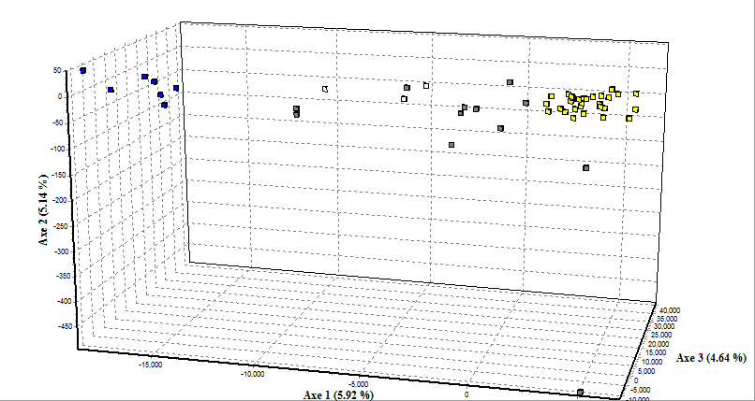

Figure S2: Principal Component Analysis (PCA) of first and second axis of individual microsatellite genotypes of S. coeruleoalba (Stenella, dark green squares), D. delphis (Delphinus, dark blue squares), morphologically intermediate morphs (MI, turquoise squares), and individuals of both species that occupy the in between space, overlapping with that occupied by individuals of intermediate morphology described as genetically intermediates (U, pink squares), also characterized as hybrids according to the hybridization analyses conducted in this study. Inset represents the eigenvalues of the 10 first axes with the first three being highlighted.

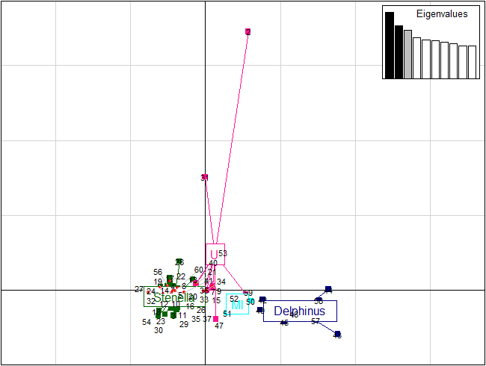

Figure S3: Inference of population structure with the use of two different methods. A) Barplot of STRUCTURE individual’s membership coefficients (Q) in each of the inferred clusters (K=3). MI indicates Morphological Intermediates. B) Discriminant Analysis of Principal Components (DAPC): on the left is the plot of Bayesian Inference Criterion (BIC) values versus the number of clusters (K) where K=2 is the optimal number of populations and on the right the inferred ancestry with K=2.
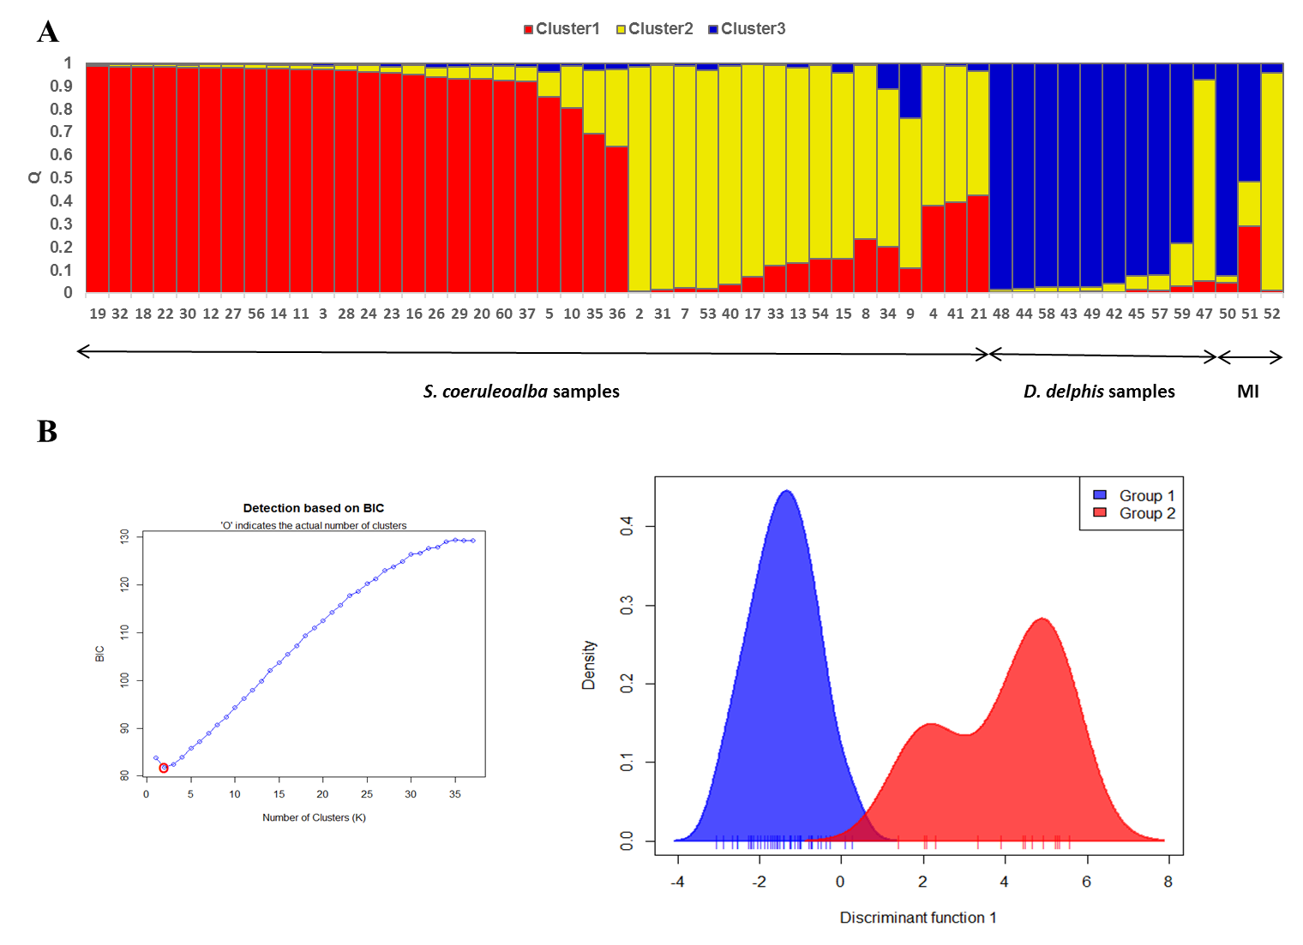

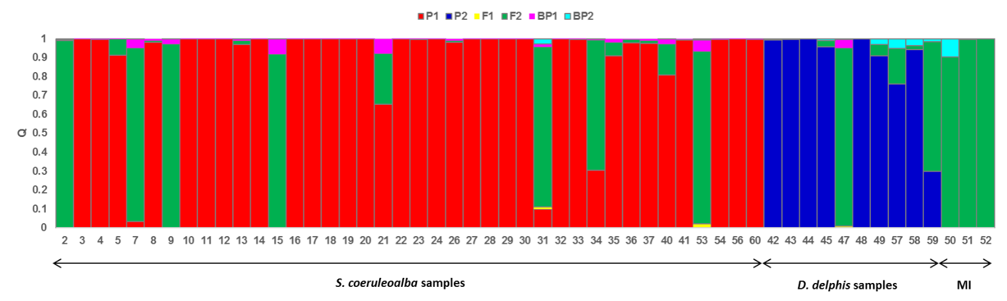
Figure S4: Bayesian assignment of multilocus genotypes of real dolphin samples analysed in the present study using the software NewHybrids (i.e., NewHyrids 1st Run). Each line represents an individual’s posterior probability of assignment (Q) to each of the six categories: two pure parental populations corresponding to the two species that hybridize (P1, P2), their F1 hybrids as well as the F2 hybrids and backcrosses of F1 hybrids with either parental population (BP1, BP2 respectively). MI indicates Morphological Intermediates.

References
Amaral, A.R., Beheregaray, L.B., Bilgmann, K., Boutov, D., Freitas, L., Robertson, K.M., Sequeira, M., Stockin, K.A., Coelho, M.M., Moller, L.M., 2012a. Seascape Genetics of a Globally Distributed, Highly Mobile Marine Mammal: The Short-Beaked Common Dolphin (Genus Delphinus). PLoS One 7 (2).
Amaral, A.R., Beheregaray, L.B., Bilgmann, K., Freitas, L., Robertson, K.M., Sequeira, M., Stockin, K.A., Coelho, M.M., Moller, L.M., 2012b. Influences of past climatic changes on historical population structure and demography of a cosmopolitan marine predator, the common dolphin (genus Delphinus). Mol. Ecol. 21 (19), 4854-4871.
Amaral, A.R., Sequeira, M., Martínez-Cedeira, J., Coelho, M.M., 2007. New insights on population genetic structure of Delphinus delphis from the northeast Atlantic and phylogenetic relationships within the genus inferred from two mitochondrial markers. Mar. Biol. 151 (5), 1967-1976.
Coughlan, J., Mirimin, L., Dillane, E., Rogan, E., Cross, T.F., 2006. Isolation and characterization of novel microsatellite loci for the short-beaked common dolphin (Delphinus delphis) and cross-amplification in other cetacean species. Mol. Ecol. Notes 6 (2), 490-492.
Cunha, H.A., de Castro, R.L., Secchi, E.R., Crespo, E.A., Lailson-Brito, J., Azevedo, A.F., Lazoski, C., Sole-Cava, A.M., 2015. Molecular and Morphological Differentiation of Common Dolphins (Delphinus sp.) in the Southwestern Atlantic: Testing the Two Species Hypothesis in Sympatry. PLoS One 10 (11), 1-15.
Krutzen, M., Valsecchi, E., Connor, R.C., Sherwin, W.B., 2001. Characterization of microsatellite loci in Tursiops aduncus. Mol. Ecol. Notes 1 (3), 170-172.
Milinkovitch, M.C., Meyer, A., Powell, J.R., 1994. Phylogeny of all major groups of cetaceans based on DNA sequences from three mitochondrial genes. Mol. Biol. Evol. 11 (6), 939-948.
Moura, A.E., Nielsen, S.C.A., Vilstrup, J.T., Moreno-Mayar, J.V., Gilbert, M.T.P., Gray, H.W.I., Natoli, A., Möller, L., Hoelzel, A.R., 2013. Recent Diversification of a Marine Genus (Tursiops spp.) Tracks Habitat Preference and Environmental Change. Syst. Biol. 62 (6), 865-877.
Valsecchi, E., Amos, W., 1996. Microsatellite markers for the study of cetacean populations. Mol. Ecol. 5 (1), 151-156.
Xiong, Y., Brandley, M.C., Xu, S.X., Zhou, K.Y., Yang, G., 2009. Seven new dolphin mitochondrial genomes and a time-calibrated phylogeny of whales. BMC Evol. Biol. 9, 20.

